CS4321 Introduction to Algorithms

Final Exam
(100 possible points)
December 18, 2007

Name:

Problem | 1 | 2 | 3 | 4 | 5 | 6 | 7 | 8 | 9 | 10 | 11 | Total
Point

- (4 points) Given the following disjoint-forest implementation of disjoint sets,
  - (1 point) What does findSet(7) return?
  - (3 point) Show the structure after union(1, 7) is called. What is the rank of the united tree?
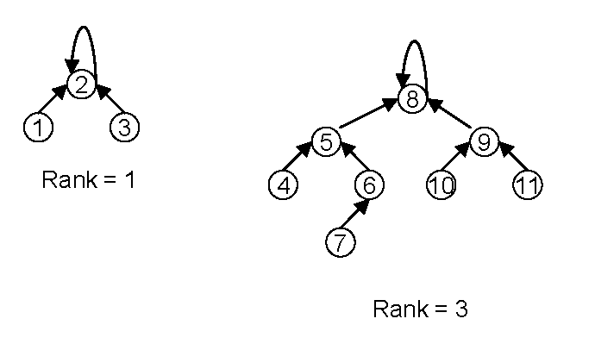
- (5 points) Draw the splay tree after insert(25) is called on the splay tree below. Show each splaying step. (For simplicity, the external nodes are not shown and you need not to draw them).
17
15
26
10
29
12
31
23
18
20
24
- (8 points) The following questions are related to quicksort and the partition algorithm is given.
  - (5 points) What is the best case cost of quicksort? When does it happen? Justify your answer.
  - (3 points) If we use quicksort to sort array A[9] = {8, 21, 11, 9, 17, 7, 20, 1, 15}. Show the content of array A after first time partition(), i.e., partition(A, 0, 8), is called. What value does this call return?
int partition(A, p, r)
{
x = A[r]; // use A[r] as the pivot
i = p-1;
for (j=p; j<=r-1; j++) {
if (A[j] <= x) {
i++;
exchange(A[i], A[j]);
}
}
exchange(A[i+1], A[r]);
return i+1;
}
- (12 points) In the matrix-chain multiplication algorithm, an array m[][] is used to track the optimal solution (minimum number of scalar multiplications) and an array s[][] is used to keep track of the split point for the optimal parenthesization. The table below shows the process of the algorithm for calculating the product of ABCD where A is 95, B is 57, C is 712 and D is 124. The value in cell (i, j) is m[i][j] and the value in the bracket is s[i][j].

i j | 1 | 2 | 3 | 4
1 | 0 | 315(1) | 960 (1)
2 |  | 0 | 420 (2) | 476 (2)
3 |  |  | 0 | 336 (3)
4 |  |  |  | 0

  - (3 points) Calculate m[1][4] and s[1][4] for cell (1, 4).
  - (2 points) What’s the optimal parenthesization for chain ABCD in this problem?
  - (4 points) With the input of n matrices, M[1..n] plus m[][] and s[][] obtained from the matrix-chain multiplication algorithm, write a pseudo-code algorithm that outputs the product of the chain using minimum number of scalar multiplications. You can directly call matrixMul(A, B) (discussed in class) which returns the product of A and B.
  - (3 points) What’s the cost of your algorithm? Justify your answer.

- (11 points) We are running depth-first search on the graph below and assuming that the searches visit the neighbors of a node and the sources in numerical order (smaller first).
- (2 points) Draw the depth-first search tree (or forest).
- (4 points ) Give the discovery time and finishing time of each vertex.
- (3 points) Classify the non-tree edges as back, forward, and cross edges.
- (2 points) Does there exist a topological ordering for the graph? If yes, give an ordering. If no, justify.

1
2
6
3
4
7
5
8
9

- (12 points) We are running one of the four algorithms on the graph below. (ignore the directions on the edges for Prim's and Kruskal's).
- Prim's for the minimum spanning tree starting from node 1
- Kruskal's for the minimum spanning tree
- Dijkstra’s for single source shortest path where the source is node 1
- Floyd’s all-pair shortest path
- (3 pts) Show the order of nodes that are added to the partial solution by the Prim’s algorithm.
- (2 pts) What is the second edge added by Kruskal's algorithm to the partial solution?
- (3 pts) Dijkstra’s algorithm uses an array d to record the distances of shortest special path. Given the content of d after the shortest path of node 2 is discovered.
- (1 pts) Give the adjacency matrix for the graph.
- (3 pts) What is D after the first iteration of Floyd’s algorithm, in other words, what is D₁?

7
12
9
1
2
4
3
14
10
5

- (10 points) In the following flow network, each edge is annotated with its flow (on the left) and capacity (on the right).
- What is the capacity of cut χ = {(s, 1, 4); (2, 3, 5, t)} as denoted as dashed line?
- What is the flow through cut χ?
- Is the path with the bolding edges an augmenting path? Why?
- What is the residual capacity of edge (1,3) with resprect to the path of the bolding edges.
- What is the maximum flow for this network?
s
1
4
3
2
5
t
7/9
3/3
5/7
4/6
8/9
4/5
4/4
3/3
3/8
3/7
2/3


- (6 points) Below is a dynamic programming table for calculating the longest common subsequence of x = <B, A, C, B> and y = < B, A, A, B, C>.
  - (2 points) Fill the empty slots.
  - (2 points) What is the meaning of “3” at cell (4, 4)?
  - (2 point) What is the longest common sequence derived from this table?
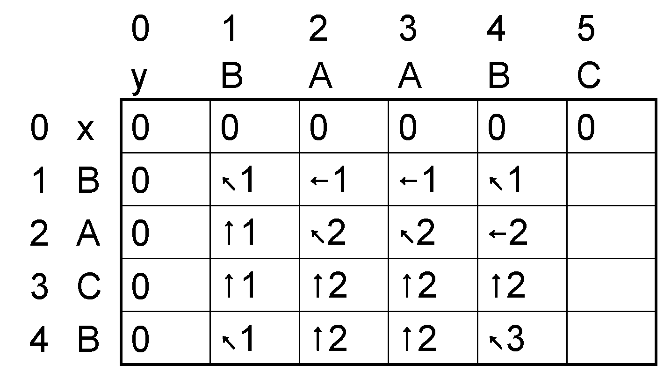
- (6 points) Professor Greedy drives an automobile from Newark to Reno along Interstate 80. His car’s tank, when full, holds enough gas to travel n miles, and his map gives distances between gas stations on his route. The professor wishes to make as few gas stops as possible along the way. Give an efficient method by which Professor Midas determine at which gas stations he should stop, and prove that your strategy yields an optimal solution.

- (10 points) We are going to design a k-way merge operation. Suppose you have k sorted arrays, each with n elements, and you want to combine them into a single sorted array of kn elements. (For simplicity of analysis, you can assume that k is an exact of power of 2).
  - (3 points) Here's one strategy: Using the merge procedure discussed in class, merge the first two arrays, then merge in the third, then merge in the fourth, and so on. What is the time complexity of this algorithm, in terms of k and n?
  - (7 points) Give a more efficient solution to this problem, using divide-and-conquer. Your algorithm should be asymptotically faster than the strategy in (a). Justify the cost the your algorithm.

- (16 points) We are given as input a sequence L of n numbers, and must partition it into as few contiguous subsequences as possible such that the numbers within each subsequence add to at most 100. For instance, for the input [80, -40, 30, 60, 20, 30] the optimal partition has two subsequences, [80] and [-40, 30, 60, 20, 30]. We know that each number in L is no greater than 100. We are going design a greedy algorithm and a dynamic programming algorithm to solve this problem.
- (3 points) Write a pseuocode greedy algorithm for this problem.
- (2 points) Is your greedy algorithm optimal? If yes, prove it. If no, give a counter example.
- (3 points) Let C[i] denote the number of subsequences in the optimal solution of the subproblem consisting of the first i numbers, and suppose that the last subsequence in the optimal solution for all of L has k terms; for instance, for the same example as above, C[3] = 1 (the subproblem [80, -40, 30] needs only one subsequence) and k = 5 (the optimal solution for L has five numbers in the last subsequence). Give a dynamic programming recurrence for C[i].
- (5 points) Give an efficient dynamic programming algorithm to compute the length of the optimal partition and keep tracks how to partition. Please write your algorithm in pseudo-code and explain how it works.
- (3 points) What’s the cost of your algorithm? Why?

